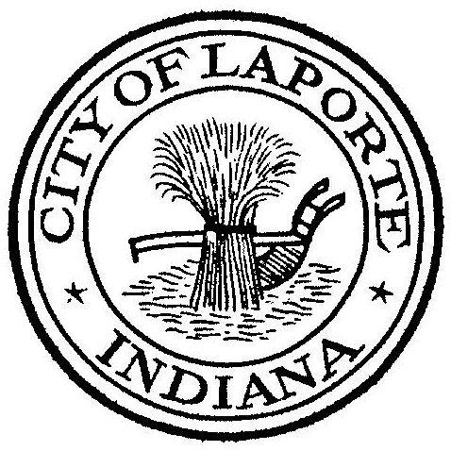
Board of Public Works and Safety
Jessica Romine, Member Tom Dermody, Mayor Mark Kosior, Member
City Hall 801 Michigan Ave., La Porte, IN 46350
Tuesday, January 4, 2022
9:00 AM
AGENDA
- Call To Order
- Pledge Of Allegiance
- Approval Of Minutes
- Public Comment: via Facebook Live
- Clerk-Treasurer: Claims Approval
- Department Head Reports
- New Business:
-Employee Passes/Time Off for NIBC Tournament
-Jen Noll: Update Communicable Disease Policy
-Nick Minich: Request Approval of Des. No. 1601867 Plan Set-(Chessie Plan 2)
Request Approval INDOT LPA Grant Agreement Des. No 2101444-(2021 CCMG
Paving)
Receive Bids for the Tree Planting Project
8) Unfinished Business:
- Other Business:
10 Adjourn

